Circle Members’ Trip to The Peach Orchard, Gettysburg National Battlefield Park, 09/23/17

The Explorations in Consciousness Circle went on its fourth, annual field trip to Gettysburg National Battlefield Park, PA., this time to the Peach Orchard, the place where, on the second day of the Battle of Gettysburg (July 1-4, 1863), Confederate soldiers engaged and eventually pushed the Union forces to retreat, but only after both sides had incurred many casualties.
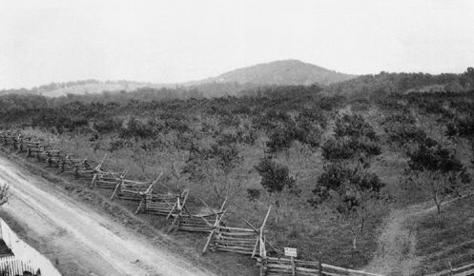
The Peach Orchard As It Was During the War.
Big Round Top is the large hill in the distance, center right; Little Round Top is to its left. The Wheatfield is in the direction of Little Round Top, about an eighth to a quarter mile away; it borders on the right side of the larger dirt road seen here.
Picture found via Google “The Peach Orchard Gettysburg-Bing Images”

On these field trips, our mission is to invite spirits of the dead on both sides, who have been wandering the battlefields for over 150 years, to go into the Light. In her description of what transpired on this trip, one of the Circle members wrote the following words, which capture what we always seek:

We carried our folding chairs into the Peach Orchard as the sun was beginning to set. We sat in a circle and took out the hardtack crackers that Joe had made and placed them in front of us–-as a symbol of solidarity with the soldier spirits. [Hardtack, made from flour, salt and water, was the staple food of both Armies; it was rock hard and often filled with vermin.] As a barn owl came to observe, Joe started the ceremony. I felt a strong angelic presence as Joe was setting the stage to bring the lost spirits into the Light. Our Circle beamed with the light of unconditional love, and it created a bridge. I could see soldiers; some were lying down. They had forgotten they could stand up. Some were missing limbs. One stood right in front of me, his face black with dirt and yet showing a huge grin. Waves of gratitude came towards us as the spirits were moved by our remembrance, our love, and then turned into the Light – they became like fireflies as they ascended into the sky. In connecting with this land where blood was shed, I found the Earth to be at peace. She had long since transmuted the blood and much of the pain and suffering that went with it. I could see an endless river of living flowers covering the ground between the trees. “Look” said Mother Earth, “This is what I made of man’s insanity.” A steady stream of spirits was gently making its way to the Light when Jenny Avila began singing her beautiful song, "Warrior Spirit and the Keeper of the Bones.” The spirits expressed utter joy that someone had come to sing to them. More came from over the hilltops to see and to listen. They were so deeply moved by the outpouring of love. This was not a reenactment, meant to sow the seeds of suffering. This was something meant for them. This was their call to come Home.

As Jennifer notes, we had the honor of having Jennie Avila, songwriter and singer
with us on this trip. Before we had gotten onto the road to Gettysburg, we had a potluck, early dinner, accompanied by Jennie strumming her guitar and singing several of the Civil War songs she had composed and are on her two CDs, Love and Lore of the Civil War, and Civil War Stories in Song. At the Peach Orchard she sang a capella the haunting song Jennifer cites, one so very appropriate to our mission at the Peach Orchard.

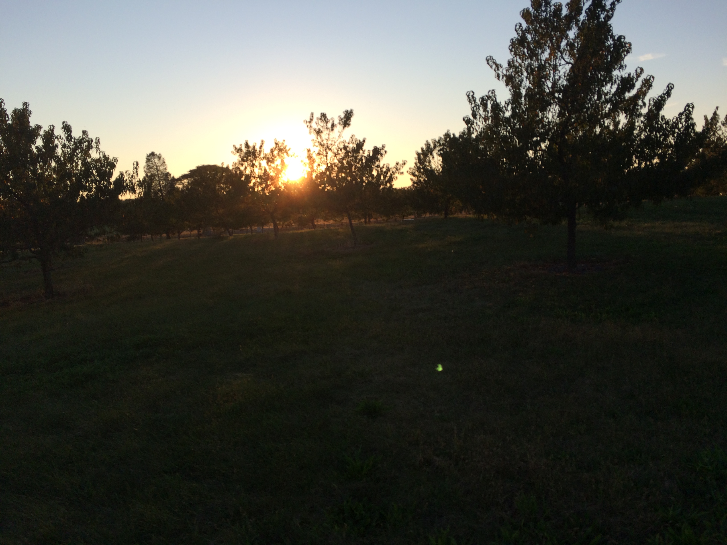
Sun Setting Over the Peach Orchard, Taken by Jennifer
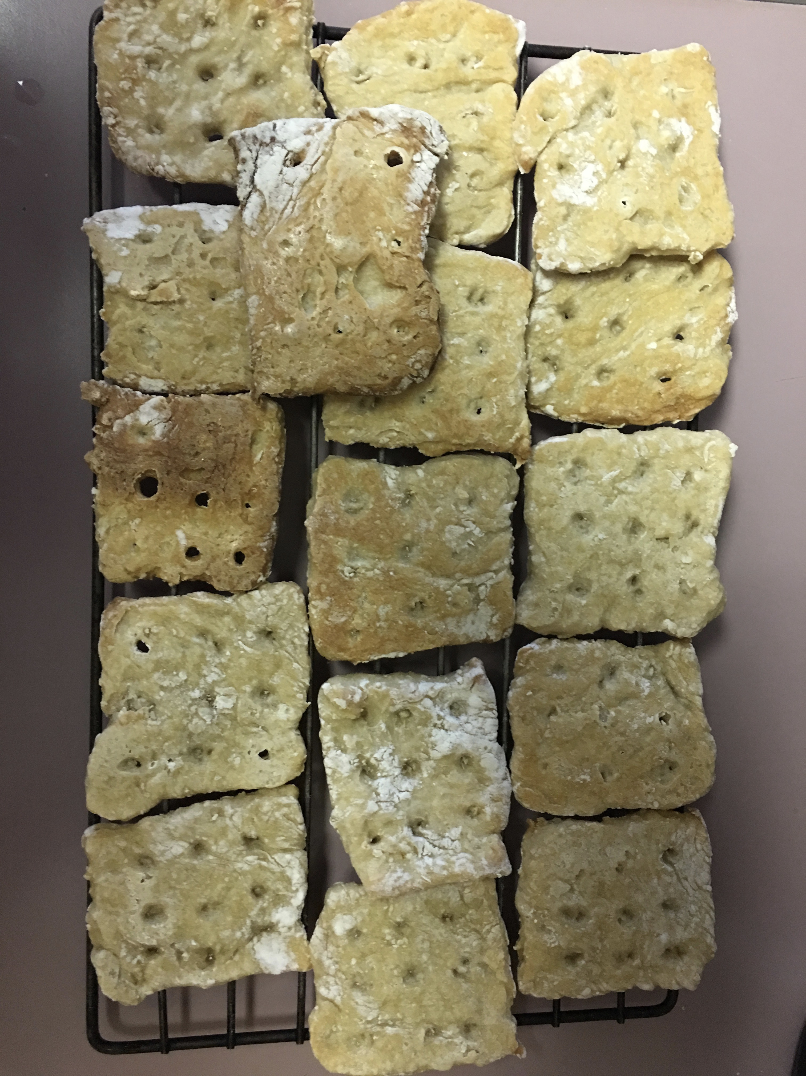
Moon Over the Peach Orchard, Taken by Joe Hardtack Made By Joe
Another Circle member, Patsy, wrote of her experiences:
First, I saw a large bird with yellowish wings land on a tree branch about 300 yards from where my group had gathered. At that distance, at first, it was impossible to identify the type of bird (which was later found to be a Yellow Barn Owl); and it sat on the branch waiting for something. It should be noted, that the bird arrived just after the Circle was listening to our leader, Joe, give a very brief history of the importance of our site, the Peach Orchard, to the events that transpired during the three-day Battle of Gettysburg. After Joe finished his explanation and our group was about to embark on a meditation, there was a sudden movement in the distance; and the now identified owl flew off. Our Circle continued to be guided by Joe; and, as dusk fell and the skies darkened, I noticed three lights in the distance where there was a thick area of trees. The lights were stationary, almost like three people were holding some kind of illumination. At first, I thought the lights might be from motorcycles or a very strong, laser flashlight; but the size was wrong for these sources. The lights would disappear from time to time when cars driving down the road would block them and then they would reappear. These lights remained constant while Joe was talking to Spirits, inviting those who might be present to “go into the Light.” Suddenly, the distant lights disappeared and a small lamp in a cloth bag near Joe lit up. I had no idea that there was a lamp in the bag and assumed that Joe had somehow turned it on.
The “lamp” Patsy is referring to is the small, remote-controlled, LED lamp I had brought to use as a centerpiece for the Circle. However, I had forgotten all about it. As Patsy notes, the lamp suddenly went on in the cloth bag, which had rested by my side through most of my address to the spirits. There was no way that it had been turned on by the remote, which was also in the bag, but had not been moved or even touched. A wonderful, very apropos signal that the spirits understood about going into the Light!

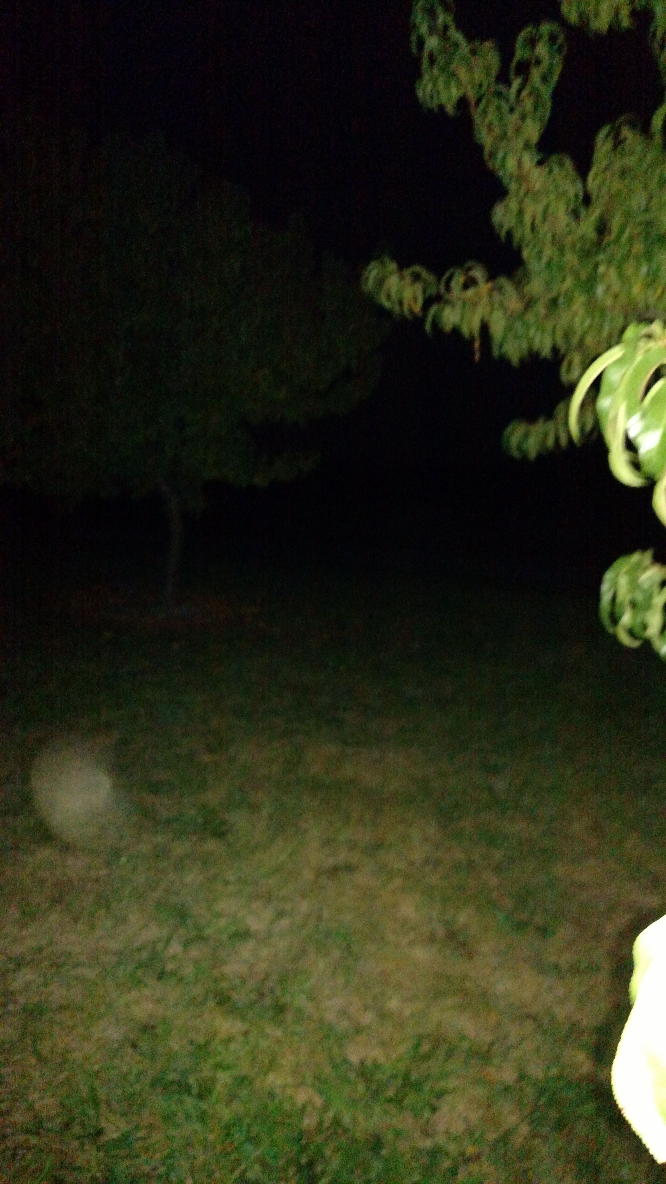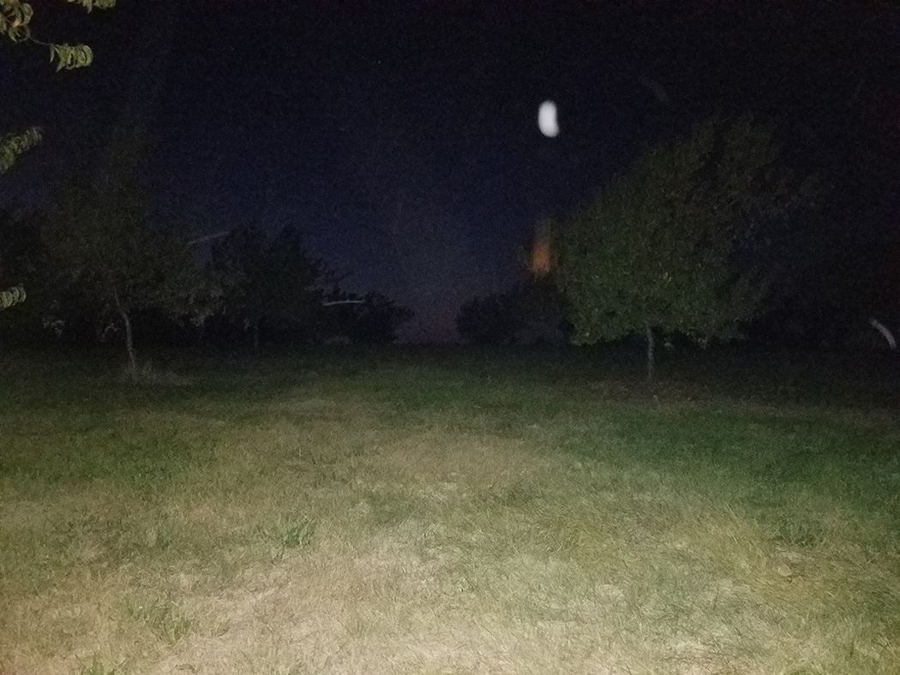
Orb in the Grass Mysterious Light (Orb?)
Taken by Patricia Taken by Patsy

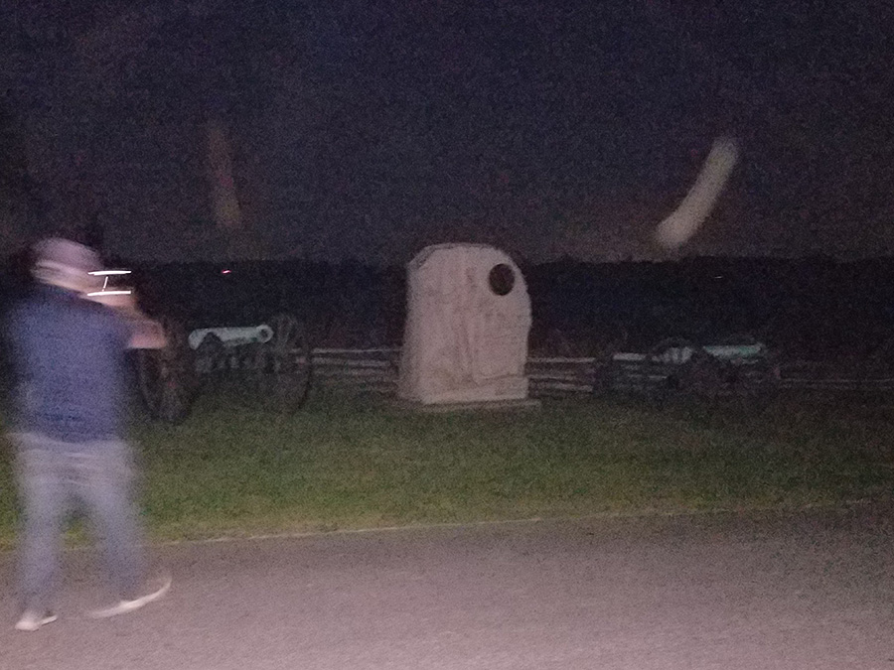
More Lights (Likely Orbs), Taken by Patsy

Facts About the Peach Orchard Battlefield in Gettysburg National Military Park 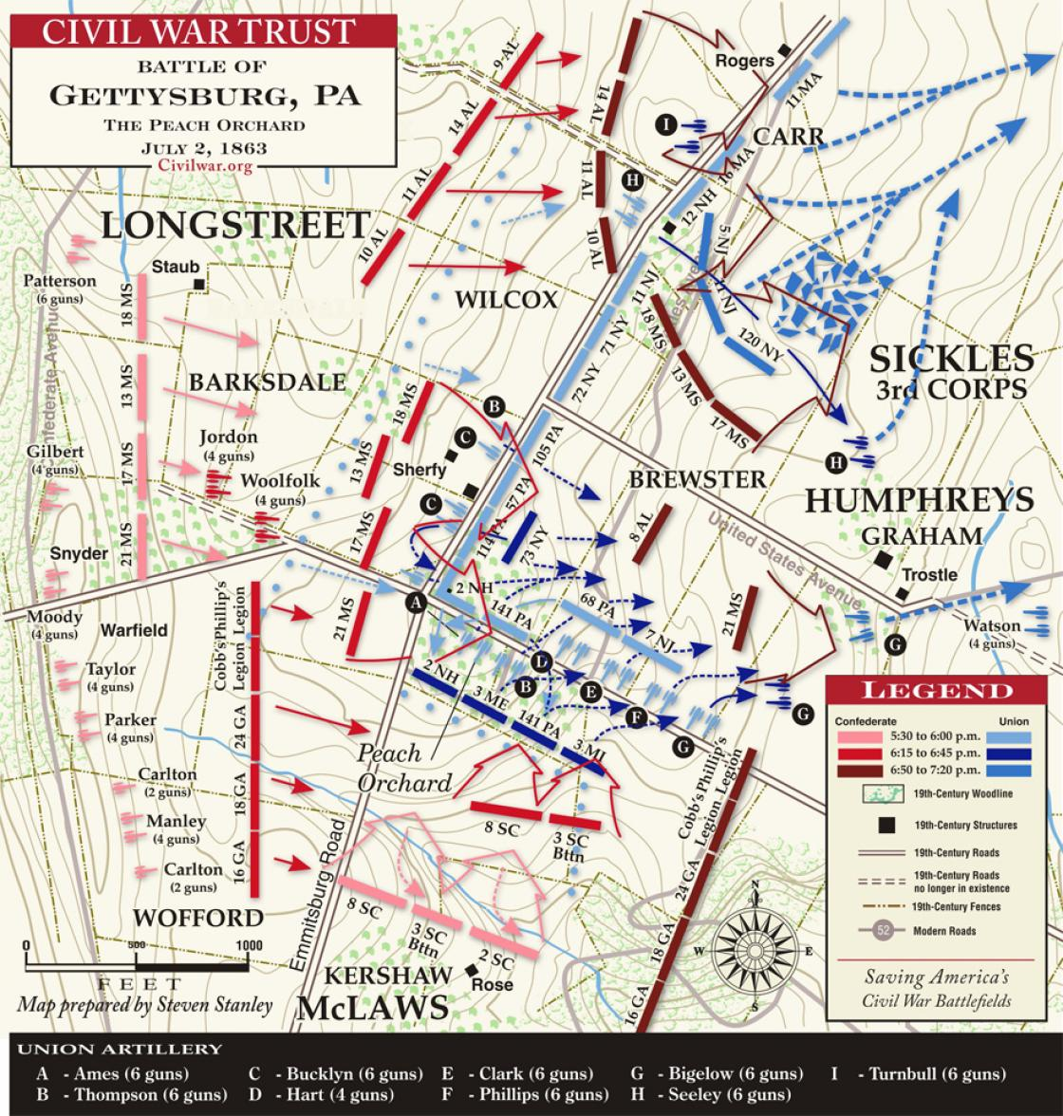

The following write-up is from http://thomaslegion.net/battleofgettysburgthepeachorchard.html:

Summary: The second day’s battle of Gettysburg was the largest and costliest of the three days. The second day’s fighting (at Devil’s Den, Little Round Top, The Wheatfield, The Peach Orchard, Cemetery Ridge, Trostle Farm, Culp’s Hill and Cemetery Hill) involved at least 100,000 soldiers of which roughly 20,000 were killed, wounded, captured or missing. The second day in itself ranks as the 10th bloodiest battle of the Civil War.

While the right wing of Kershaw's brigade [Confederate] attacked into the Wheatfield, its left wing wheeled left to attack the Pennsylvania troops in the brigade of Brig. Gen. Charles K. Graham, the right flank of Birney's line, where 30 guns from the III Corps and the Artillery Reserve attempted to hold the sector. The South Carolinians were subjected to infantry volleys from the Peach Orchard and canister [shotgun-like cannon fire] from all along the line. Suddenly someone unknown shouted a false command, and the attacking regiments turned to their right, toward the Wheatfield, which presented their left flank to the batteries. Kershaw later wrote, "Hundreds of the bravest and best men of Carolina fell, victims of this fatal blunder."

Meanwhile, the two brigades [Confederate] on McLaws's left—Barksdale's in front and Wofford's behind—charged directly into the Peach Orchard, the point of the salient in Sickles's [Union] line. Gen. Barksdale led the charge on horseback, long hair flowing in the wind, sword waving in the air. Brig. Gen. Andrew A. Humphreys's division had only about 1,000 men to cover the 500 yards from the Peach Orchard northward along the Emmitsburg Road to the lane leading to the Abraham Trostle farm. Some were still facing south, from where they had been firing on Kershaw's brigade, so they were hit in their vulnerable flank. Barksdale's 1,600 Mississippians wheeled left against the flank of Humphreys's division, collapsing their line, regiment by regiment. Graham's brigade retreated back toward Cemetery Ridge; Graham had two horses shot out from under him. He was hit by a shell fragment, and by a bullet in his upper body. He was eventually captured by the 21st Mississippi. Wofford's men dealt with the defenders of the orchard.

The advanced Union line arranged by General Sickles stretched from Devil's Den to
this point- the Peach Orchard, then angled northward on the Emmitsburg Road.
This orchard at the intersection of Wheatfield Road and the Emmitsburg Road
was owned by Joseph Sherfy whose house sat on the west side of the Emmitsburg
Road. Mr. Sherfy maintained a substantial orchard of peach and apple trees and
operated a small fruit canning business from his home. Not only were Mr. Sherfy's
orchards ruined during the battle, but his house was ransacked, his fences torn
apart by Union troops and then Confederate artillerymen, his fields were covered
with the dead, and his barn burned to the ground at the height of the fighting.
To make the Peach Orchard a strong position, four Union batteries were initially
posted here. These guns bombarded southern forces on Warfield Ridge and fired
on Kershaw's men crossing the Rose Farm to attack the Wheatfield. The batteries
continued firing until about 6:30 P.M. when a final Confederate charge by General
William Barksdale's Mississippi brigade shattered the position.

Barksdale's soldiers snapped through the thin Union line after overpowering two
Union regiments placed just west of the Sherfy house. The house was riddled
with bullets as the combatants swept around it. Wounded men crawled into the
house and barn for protection. The fiery Barksdale whipped his men forward
across the Emmitsburg Road, north of the Peach Orchard where Union gunners
and infantrymen found themselves surrounded. In the melee that followed,
Union General Charles Graham was knocked from his horse and captured
as his line disintegrated. The "Excelsior Brigade" of New York regiments,
positioned in the orchard and along the Emmitsburg Road, fought back furiously
and temporarily blocked the center regiments of the Mississippi brigade. The
73rd New York Infantry raced into fill a sudden gap in the line and hit Barksdale's
soldiers head on. It was no use- within minutes the fight in front of the Sherfy
House was over and the New Yorkers were ordered to retreat so that they
would not be outflanked by the Confederates who were then sweeping around
the tightening knots of Union defenders.

Captain Charles Phillips and gunners of the 5th Massachusetts Battery
drag a gun by the Trostle Barn as Confederates close in. With the positions
at the Peach Orchard crushed, Sickles' delicate line could no longer be held.
Closely followed by General Wofford's Georgia brigade, the Mississippi brigade
seemed unstoppable as they pushed through the Peach Orchard and into the valley
toward Cemetery Ridge. The fields ahead were filled with confused, splintered
Yankee regiments and retreating artillery, an inviting prize for the battle hardened
men. General A.A. Humphreys, in command of the Union division on the
Emmitsburg Road, resolved to fight a stubborn withdrawal and slowly pulled
his men back, stopping to turn and fire on Barksdale's men who were soon joined
by two additional southern brigades from A.P. Hill's Corps. The field between
the road and Plum Run was soon covered with blue-clad bodies as Humphreys'
men stubbornly bought time with their lives. Yet they gave most of the Union
artillery the precious time they needed to get away and reform on Cemetery
Ridge.

The following excerpt is from https://www.visit-gettysburg.com/gettysburg-peach-orchard.html:

The Peaches Survive

Before the Civil War, Gettysburg was best known for orchards of delicious fruit, but one Gettysburg peach orchard became a hot spot during the battle in 1863. The peach orchard at the intersection of Wheatfield Road and Emmitsburg Road became the scene for a confrontation between Longsteet’s Confederate troops and Sickles’ Union troops. It was the scene of intense fighting on July 2, 1863 from approximately 4pm to 6:30pm when Longstreet ordered the Confederate infantry assault. Farmer Sherfy salvaged as many of the damaged orchard trees as he could and planted new tress to replace those that died. He continued to sell canned peaches from his orchard as he had before it was touched by war, but he added an advertisement that they were from his original peach trees on the battleground! Today, the Gettysburg peach orchard has been replanted and is maintained as a recreated battlefield site. [The trees are not fruit-bearing.]

